MY SQL AND HTML JOINING

EXERCISE

SAMEERA

  CSC PALLAVARAM

**1.EXTERNAL CSS**

INPUT & OUTPUT:

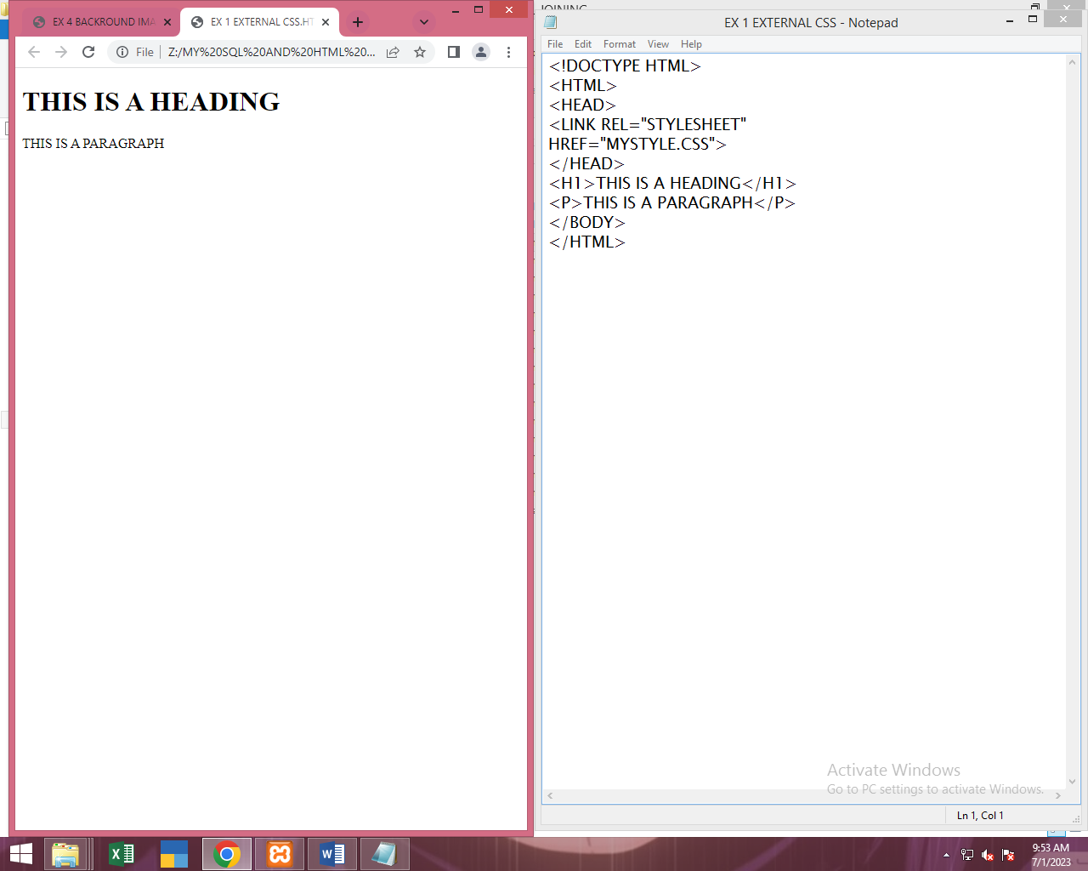

**2.INTERNAL CSS**

INPUT & OUTPUT:

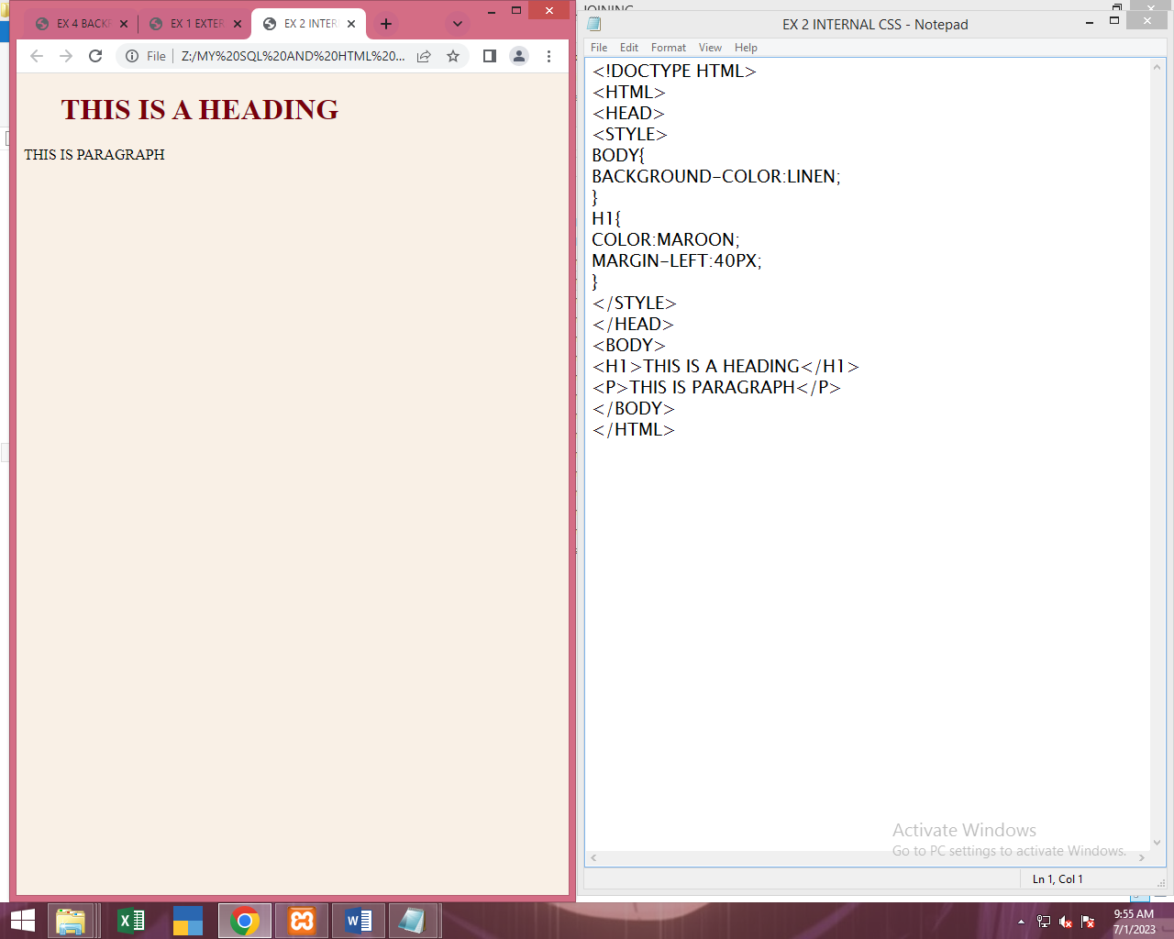

**3.INLINE CSS**

INPUT & OUTPUT:



**4.BACKGROUND IMAGE**

INPUT & OUTPUT:

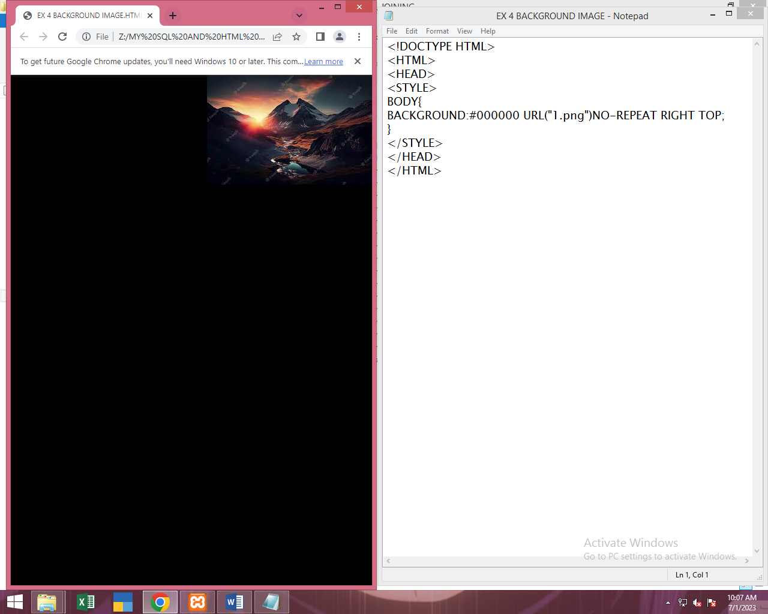

**5.BACKGROUND COLOR**

INPUT & OUTPUT:

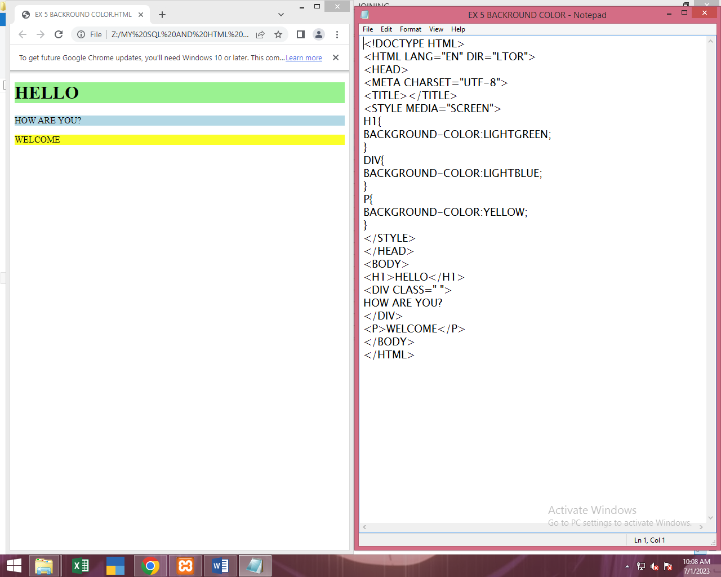

**6.BORDERS**

INPUT & OUTPUT:

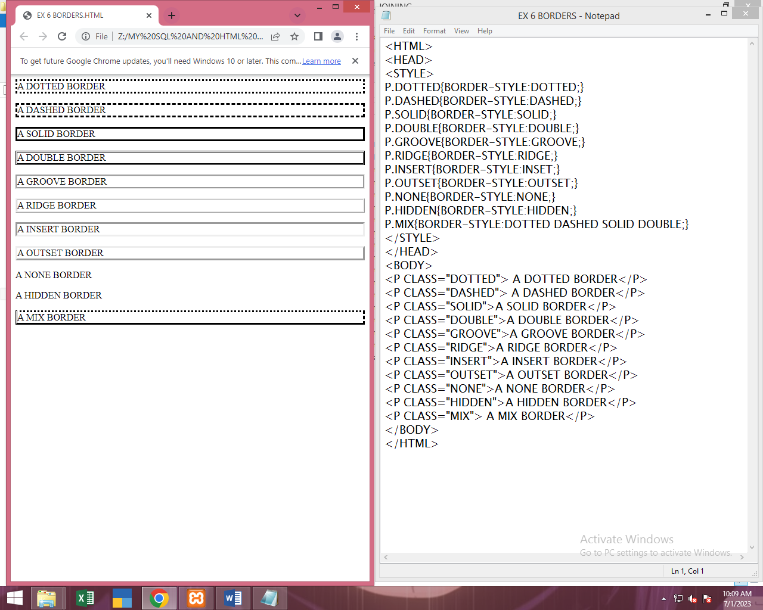

**7.1 LIST WITH STYLE**

INPUT & OUTPUT:

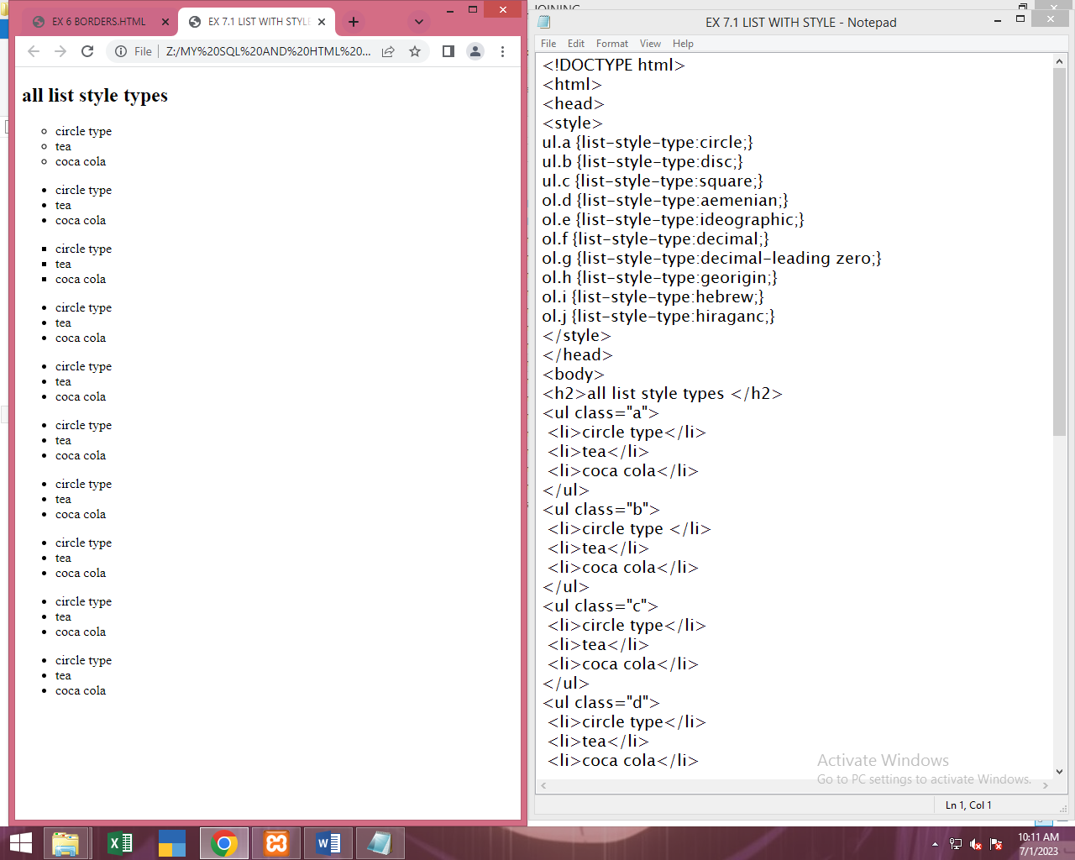

**7.2 LIST WITH COLOR**

INPUT & OUTPUT:

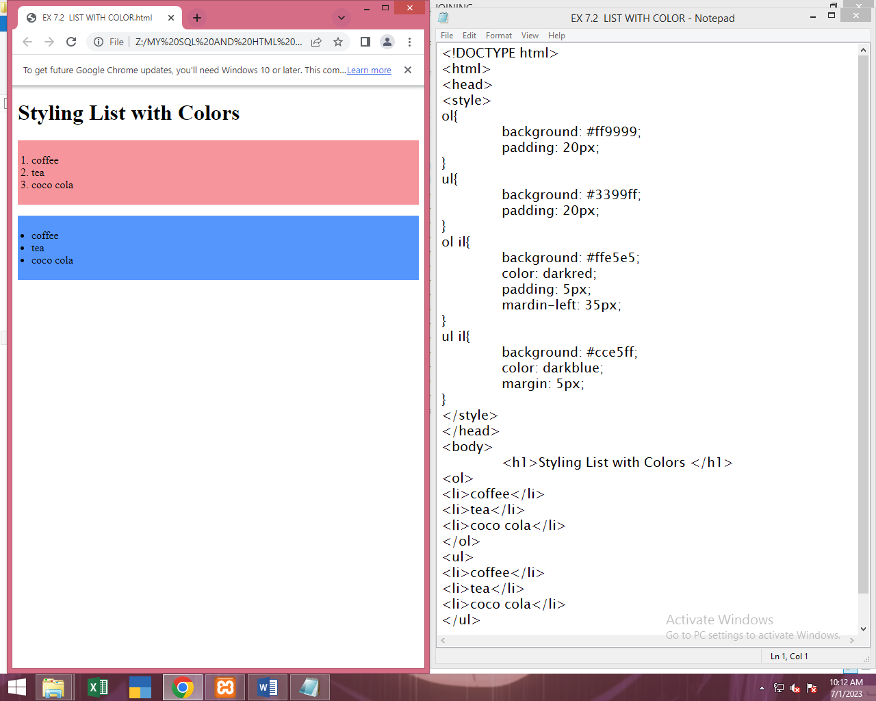

**8.TABLE TAG WITH STYLES**

INPUT & OUTPUT:

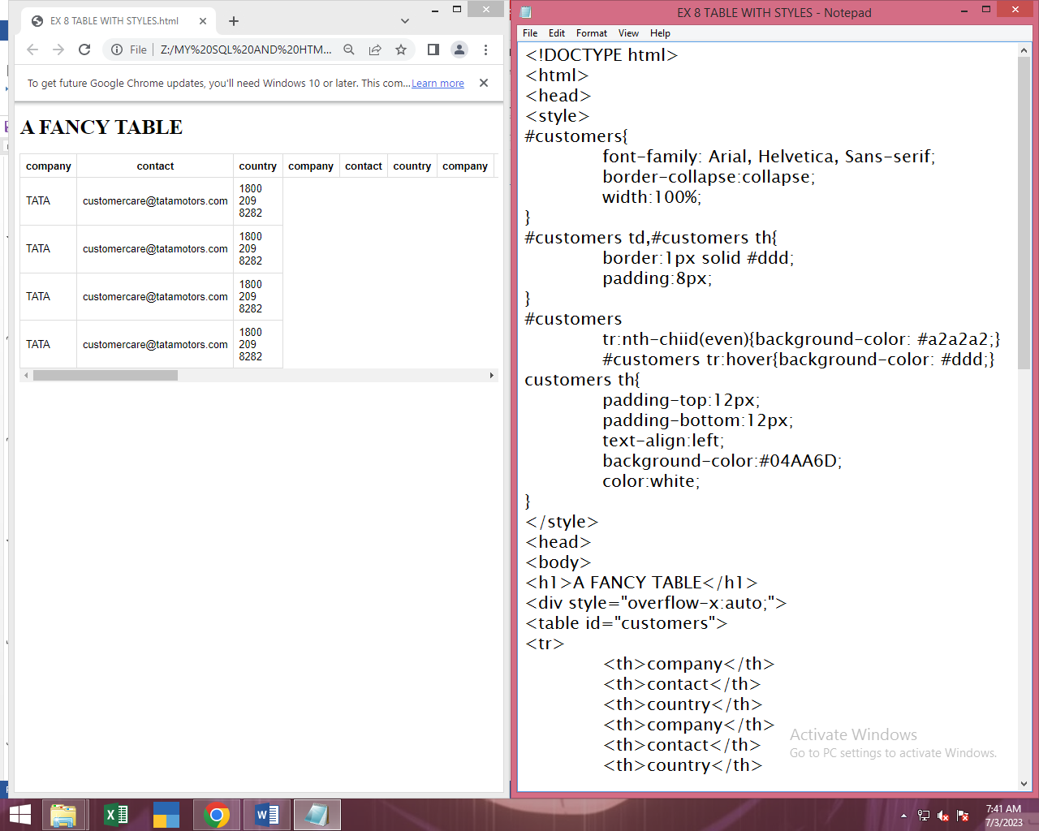

**9.FORM WITH STYLES**

INPUT & OUTPUT:

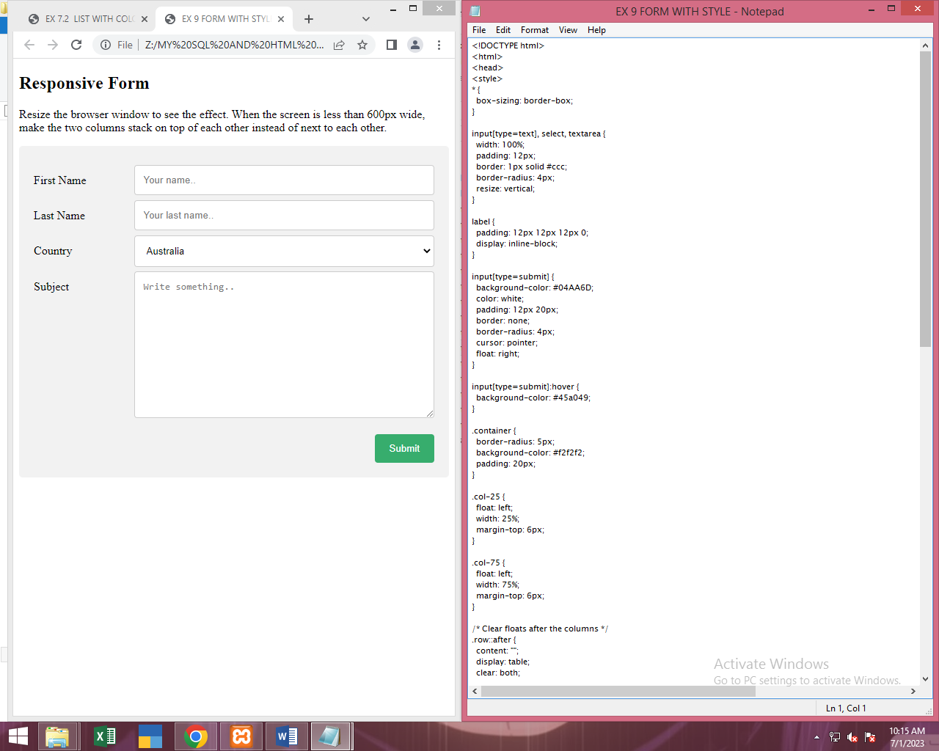

**10.VERTICAL NAVIGATION BAR**

INPUT & OUTPUT:

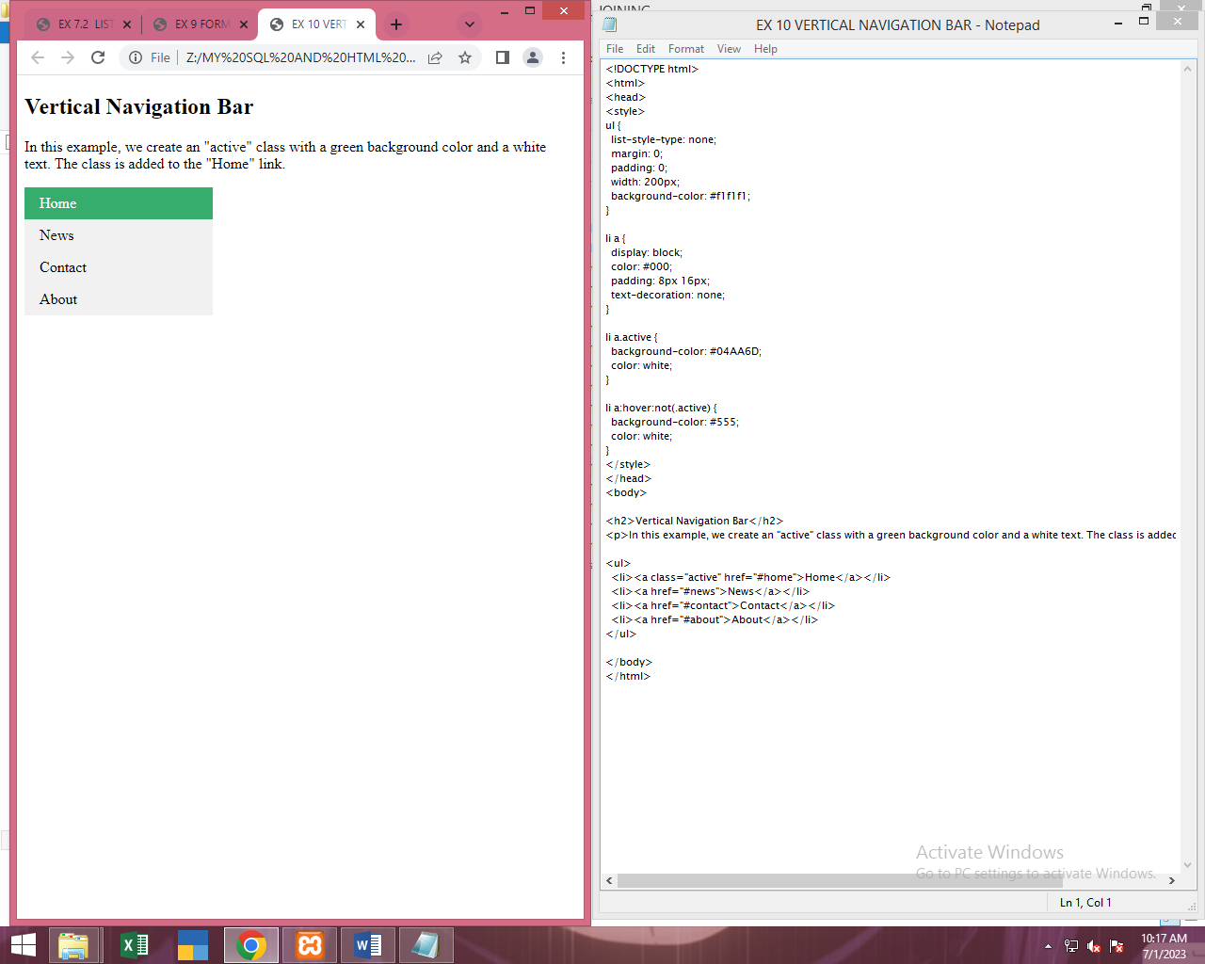

**11.STICKY HORIZONTAL NAVIGATION BAR**

INPUT & OUTPUT:

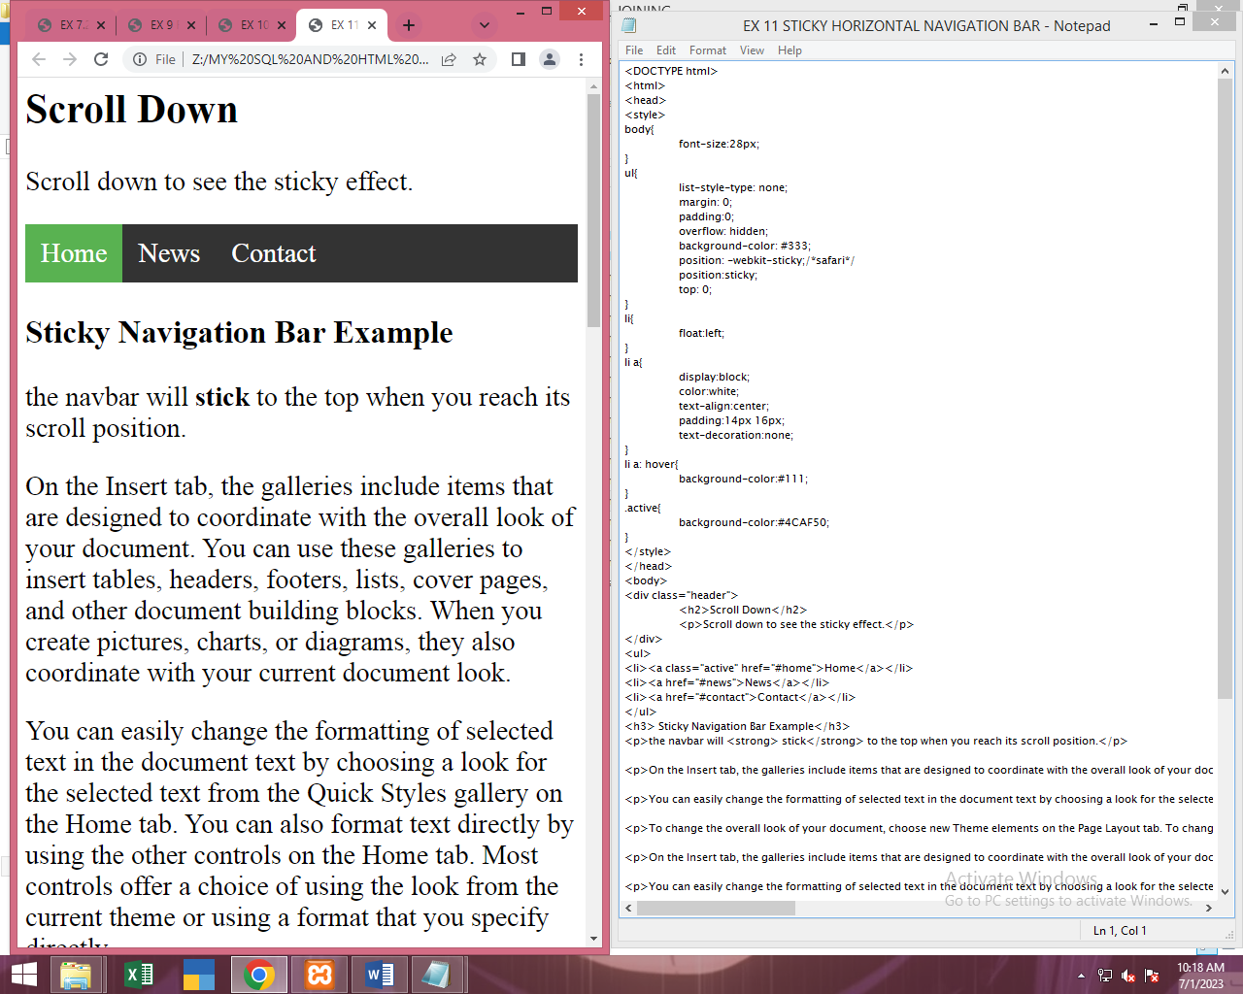

**12.1 DROP DOWN NAVIGATION BAR**

INPUT & OUTPUT;

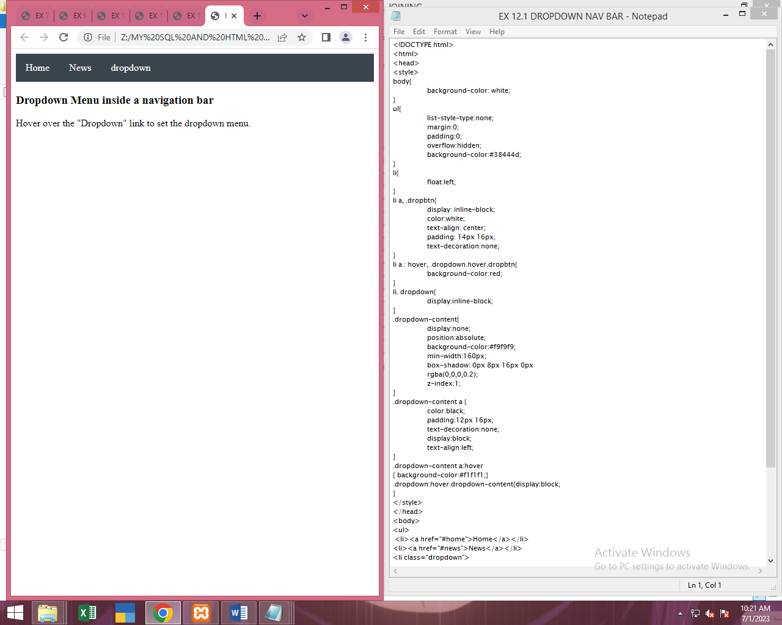

**13.TRANSITION**

INPUT& OUTPUT:

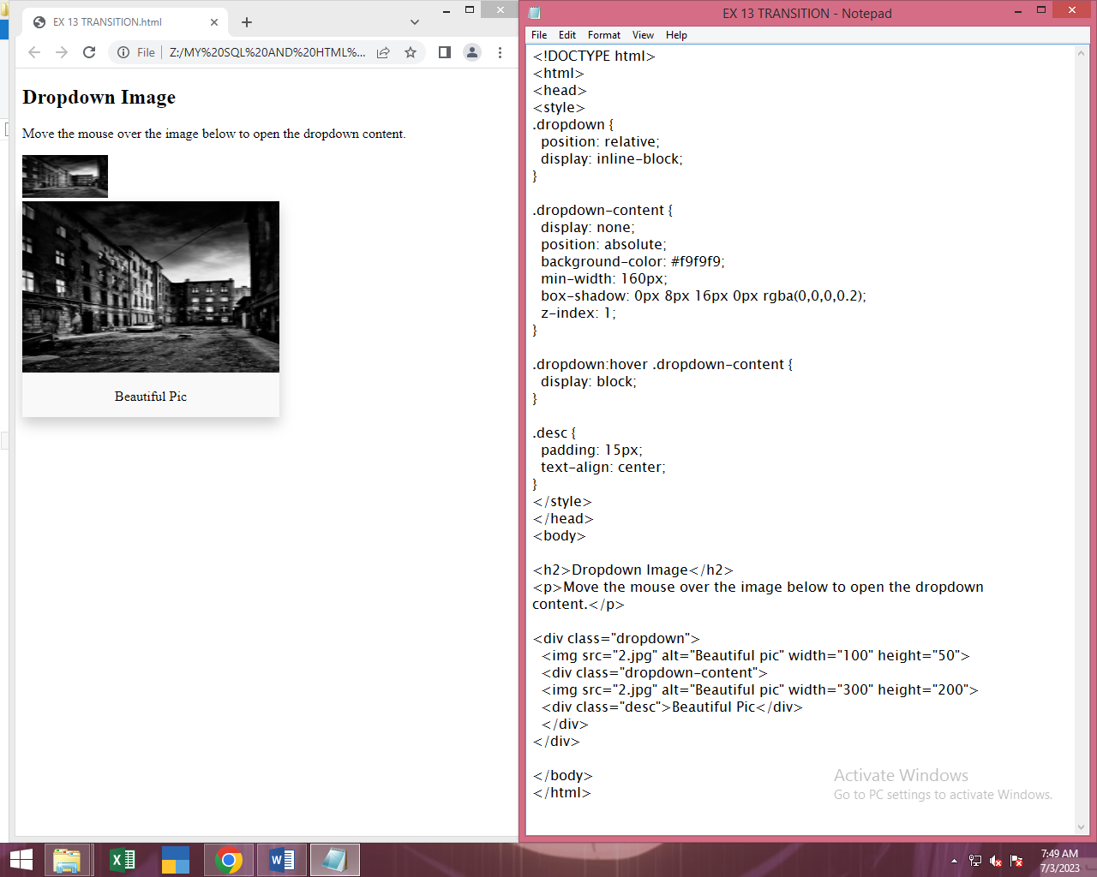

**14.ANIMATION**

INPUT & OUTPUT:

